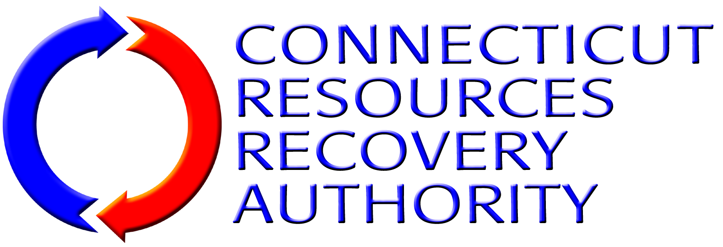
BUSINESS DISCLOSURE FORM

CONFLICTS OF INTEREST
In the space below, disclose any material assignments, relationships or other employment that the SOQ Submitter or any employee of the SOQ Submitter has with any member of CRRA’s Board of Directors,* any CRRA employee, law firms, governmental entity, or other person or entities that may create a conflict of interest or the appearance of a conflict of interest in serving as legal counsel to CRRA.
*a list of Directors is available on the CRRA website at www.crra.org
[Attach Additional Pages If Necessary]

CONFLICT OF INTEREST MEASURES
In the space below, discuss any measures that the SOQ Submitter either has in place or would take to identify, disclose and resolve any possible conflicts of interest.
[Attach Additional Pages If Necessary]

POSITIONS ADVERSE TO INTERESTS OF CRRA
In the space below, list and explain any positions that the SOQ Submitter has argued, in representing other private, municipal or public interest clients, which might be in conflict with or adverse to the interests of CRRA.
[Attach Additional Pages If Necessary]

INVESTIGATIONS
In the space below, discuss any pending or recent investigations by the Securities and Exchange Commission, the Internal Revenue Service or any other regulatory body or court (local, state or federal) regarding the conduct of the SOQ Submitter the SOQ Submitter’s management or any individuals assigned to work with the State which might affect SOQ Submitter’s ability to deliver legal services described in this RFQ. Discuss any such investigation that has occurred during the past two years.
[Attach Additional Pages If Necessary]

BUSINESS WITH MAJOR CRRA CONTRACTORS
CRRA has made payments of over $100,000 a year to the organizations named on the CRRA Vendor List on Page 6 of this Form. If the SOQ Submitter has represented any of these organizations (or their subsidiaries or affiliates), in the table below list the name of the organization, the matter(s) on which the SOQ Submitter represented the organization and the fees received from the organization in the past three (3) years. Representation of these clients will not necessarily result in disqualification from work with CRRA. The nature and extent of the representation of such clients, appropriate conflict of interest rules and the nature and extent of proposed representation of CRRA will all be considered.
[Attach Additional Pages If Necessary]
Organization | Matter on Which Represented Organization | Fees Received in Past 3 Years

CRRA Vendor List (FY 2013)
Payments Greater than $100,000
AON RISK SERVICES | HRP ASSOCIATES, INC.
ASSOCIATED ELECTRO-MECHANICS, INC. | KAINEN ESCALERA & MCHALE PC
BOLLAM SHEEDY, TORANI AND CO. , LLP, CPA | LINIUM STAFFING SVC
BOTTICELLO, INC. | METROPOLITAN DISTRICT COMMISSION
BROWN RUDNICK BERLACK ISREALS LLP | MERIDEN, CITY OF
CITY CARTING INC. | METROPOLITAN LIFE INS CO
CONN CONSTITUTION ASSOCIATES LLC | METTLER TOLEDO INC.
CONNECTICARE, INC. | NAES CORPORATION
COPES RUBBISH REMOVAL | NEXTERA ENERGY POWER MARKETING LLC
COVANTA ENERGY | NORTHEAST UTILITIES/CL&P
COVANTA MID-CONN INC. | PRESTON, TOWN OF
COVANTA SOUTHEASTERN CT | SANTA BUCKLEY ENERGY, INC.
CONNECTICUT, STATE OF, DEEP | SCS FIELD SERVICES
CONNECTICUT, STATE OF, DEPARTMENT OF REVENUE SERVICES | SOUTHEASTERN CONNECTICUT REGIONAL RESOURCES RECOVERY AUTHORITY
CWPM, LLC | SOUTHWESTERN CONNECTICUT REGIONAL RECYCLING OPERATING COMMITTEE
DIVERSIFIED TECHNOLOGY CONSULTANTS | TRC ENVIRONMENTAL CORP
ESSEX, TOWN OF | WALLINGFORD, TOWN OF
FIDELITY INVESTMENTS | WASTE MANAGEMENT OF MASSACHUSETTS, INC.
HALLORAN AND SAGE LLP | WEST HARTFORD, TOWN OF
HAMDEN, TOWN OF | WHEELABRATOR BRIDGEPORT LP
HARTFORD, CITY OF | WHEELABRATOR TECHNOLOGIES INC

